|  |
| --- |
| ELEHOME  HOME ELECTRICITY CONSUMPTION ESTIMATOR |
|  |
| JUNE 5, 2024  Conner Ngadisastra  Evan Fish |

# Application Overview

# Description

|  |  |
| --- | --- |
| Image result for home constructionEleHome is a home electricity usage estimator that allows users to model homes and determine optimal building materials and products based on the offline database that is partially pre-built from release. This application can be used to design smart homes and general-purpose homes. The application will allow users to add, edit, and delete products and materials within the database, allowing dynamic use of custom defined products.  **Targeted Platforms:** Desktop or tablet  **Potential Development Languages:** JavaScript or C# and XAML  **Potential Frameworks:** React Native or AvaloniaUI  **Projected Level of Effort:** 250 – 300 hours Features  |  | | --- | | * Use user defined properties to simulate a model home with the applied material and products. * Enable the user to add, edit, or delete home materials and products from the database. * Produce a visual graph for user feedback from the simulation data.   Data Management  Entity Relationship Diagram (Chen ERD)  The diagram includes five entities: Product, Utility, Controller, House, and Material. The ERD illustrates the relationships between each entity and their attributes.    **User Experience (UX)**  **Persona**  EleHome can be used in both professional and casual settings. Because the application is focused on presentation and results, it can be utilized by professionals such as construction contractors, as well as regular homeowners who want to compare home configurations.    **Mood Board**  The user experience (UX) of this application is designed to be easy to operate, with easy readability and a color scheme to provide user feedback. The blue and white color scheme is meant to replicate blueprints and architectural design paper. |   **User Interface (UI)**    Navigational Diagram  EleHome will include three main screens, the home (main) screen, the material database screen, and the model-home screen. When a button such as AddUtility or AddMaterial is clicked, the user is automatically guided to the corresponding tab. The navigational aspect of the application is designed to be minimal and straightforward.  A diagram of a computer screen  Description automatically generated with medium confidence |

Wireframe Diagrams

EleHome’s User Interface (UI) is designed with presentation in mind. With a clean, client presentable home page and a straight-to-the-point design showing the estimating results as well as the current home configuration.

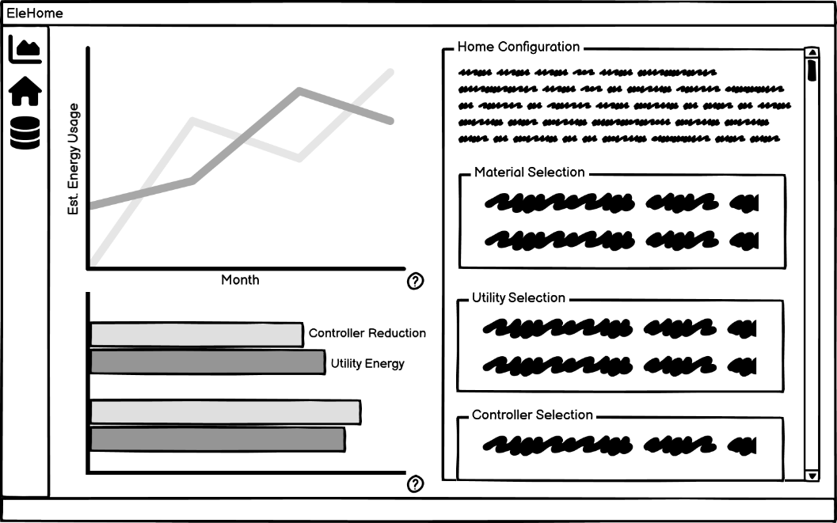

Moving to the configuration page, users are able to easily modify the home configuration. Given a clear and concise UI designed to be familiar and dynamic for desktop and large mobile platforms.

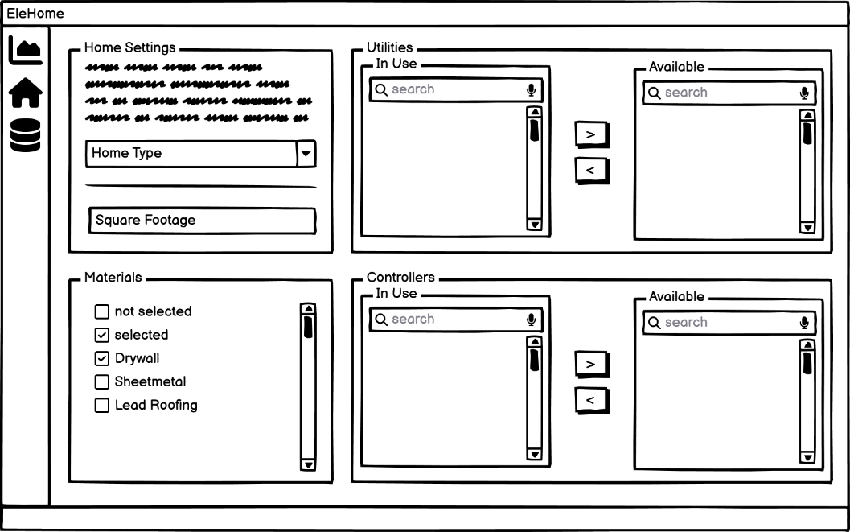

The backbone of EleHome is the dynamic database that is accessible to users via a clean list fashioned manager.

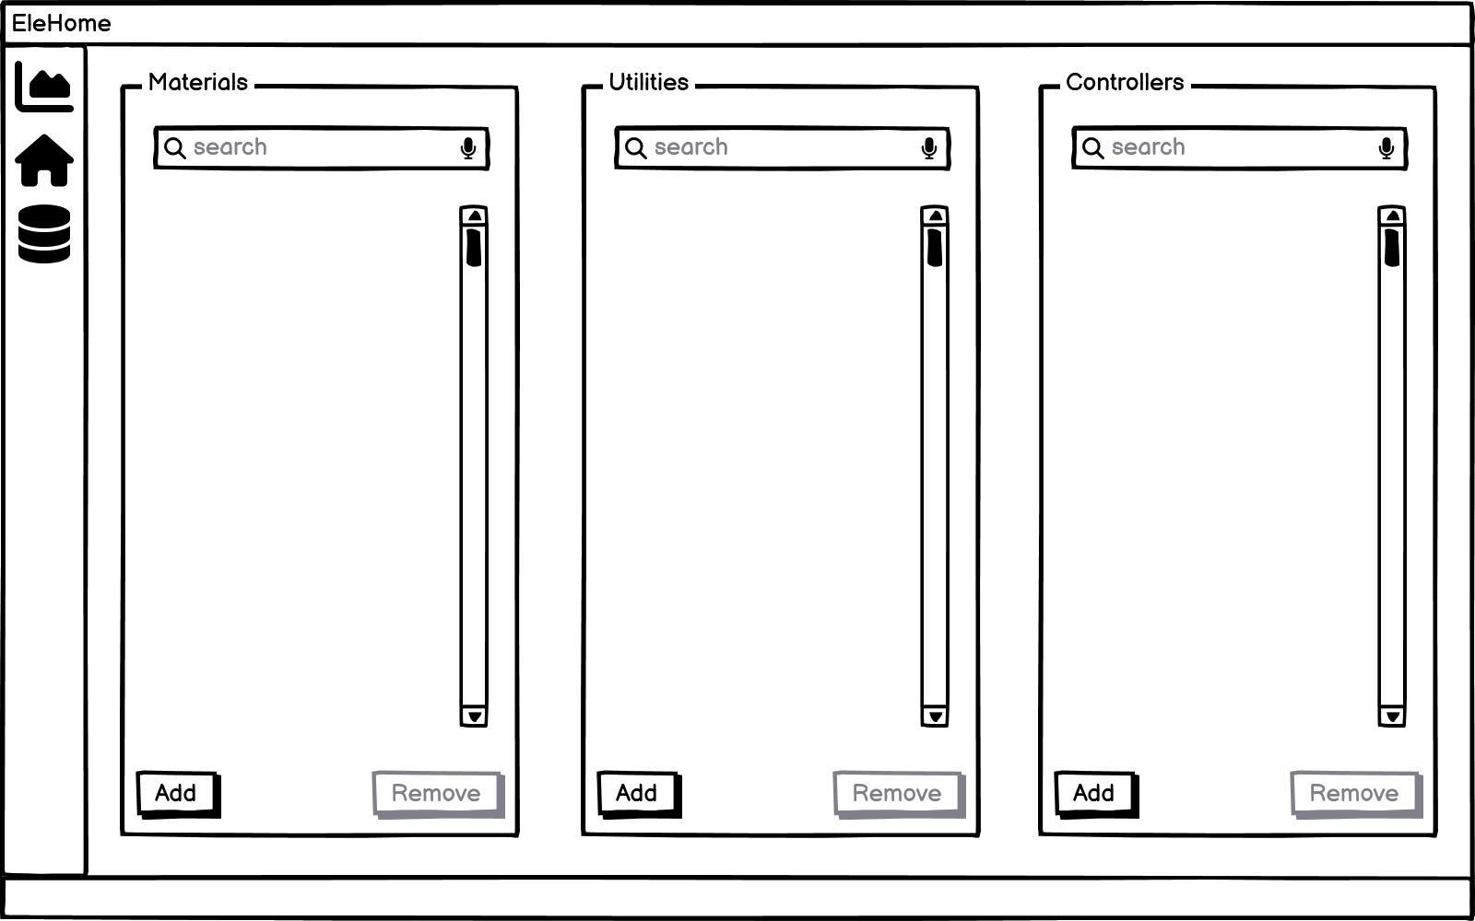

By pressing (or clicking) the add button for each database type, the corresponding modal overlay will occur as seen below.

